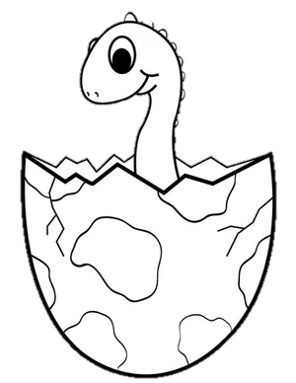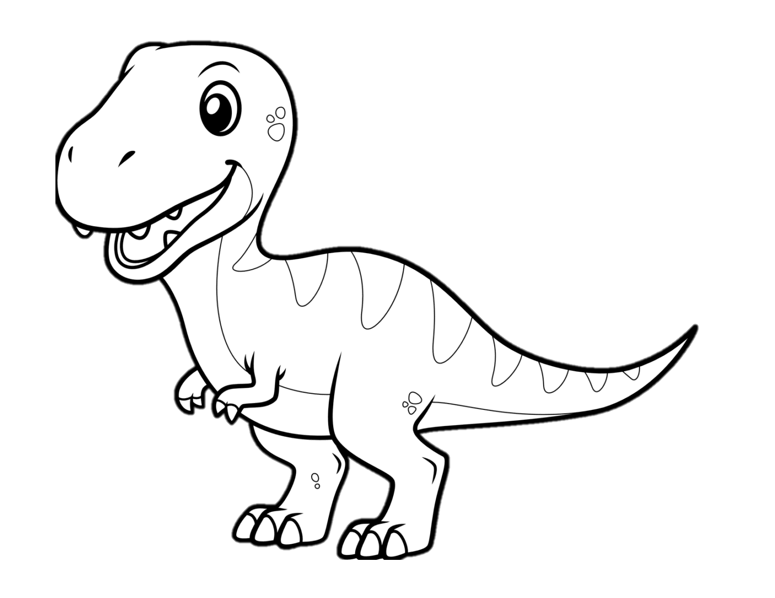­­­­­

COLOUR IN A DINO