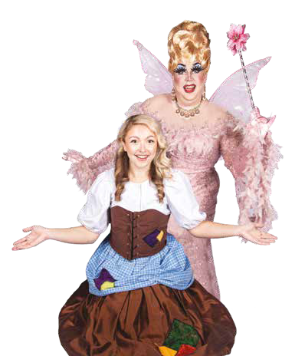
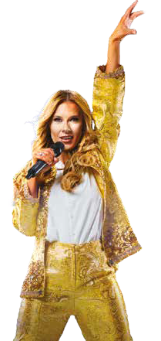
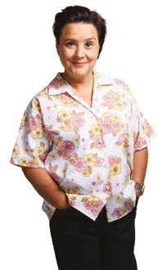




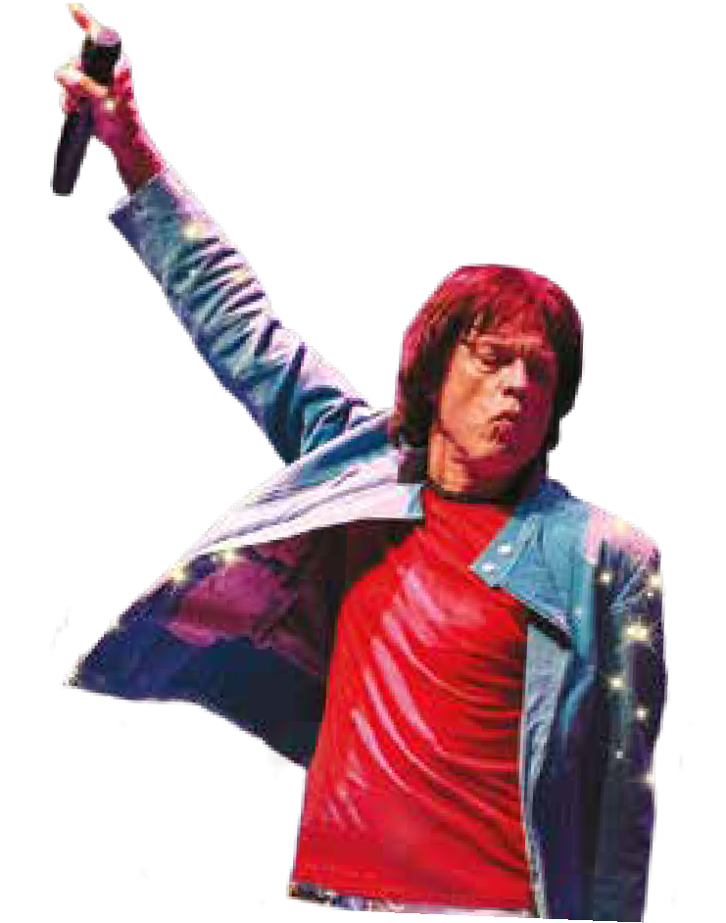


THE
CENTRAL

THEATRE
CHATHAM

WINTER 2026


MedwayTicketsLive.co.uk 01634 338338


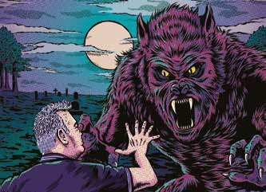
Professor Brian Cox: Emergence World Tour Fri, 28 – Sat, 29 Aug, 7.30pm

Stewart Lee vs The Man-Wulf
Sat, 19 Sep, 7.30pm
In this brand-new show for 2026, Lee shares his stage with a tough-talking werewolf comedian from the dark forests of the subconscious who hates humanity.
£31, 14+
After his smash-hit show Horizons, Professor Brian Cox is back with his new world tour, Emergence. Brian has appeared in many landmark science programs for BBC radio and television over the last 15 years.
Band A: £45, Band B: £37.50

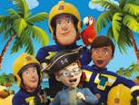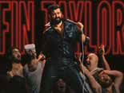

Jason Manford: A Manford All Seasons Fri, 25 Sep, 7.30pm

Jason Manford is back with his brand-new live show, A Manford All Seasons. Jason’s been busy since his last smash-hit stand up show but fans of his Absolute Radio show will know this nationally acclaimed comedian hasn’t changed a bit.
£40, 14+

Fireman Sam: The Lost Pirate Treasure

Sat, 26 Sep, 12noon

Norman Price is determined to win the Pontypandy Treasure Hunt, but when
he discovers clues to a real pirate treasure, he goes exploring deep into the caves. It’s up to Fireman Sam, Elvis and Ellie to save the day and find the treasure!
Band A: £16.50, Band B:
£15.50, concessions available

Fin Taylor

Wed, 30 Sep, 8pm

Men want to be him, women want their boyfriends to stop showing them his videos. The King of the Internet Jungle is back where he belongs, doing stand-up in front of a live audience.
£27.50
Under 16s to be accompanied by adults aged 18+

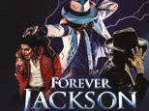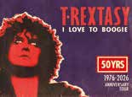

Forever Jackson

Thu, 1 Oct, 7.30pm

Forever Jackson is the world’s premiere MJ production, setting the industry alight with critically-acclaimed, sell-out shows around the world.
Band A: £28.50, Band B:
£26.50

T.Rextasy

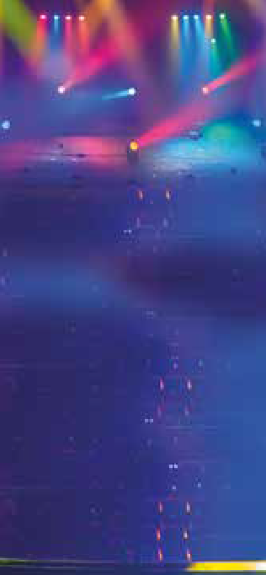
Sat, 3 Oct, 7.30pm
FOR
HIRE
For more information phone: 01634 338300 or email: theatresadmin@ medway.gov.uk

Truly a rock’n’roll concert for all ages - If you would like to know exactly what a Marc Bolan concert was like in the 1970s, this show is for you!
Band A: £31, Band B: £29

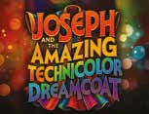
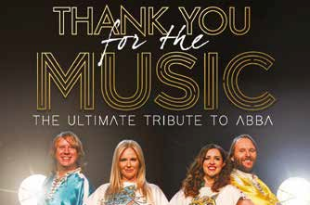
Joseph and the Amazing Technicolour Dreamcoat Wed, 7 – Sat, 10 Oct, 7.30pm

Thank You For The Music
Fri, 2 Oct, 7.30pm
Calling all Dancing Queens, this is your night to say, Thank you for the Music! This international smash-hit tribute show brings all ABBA’s number one hits to the stage in a production like no other.
Band A: £30, Band B: £28

& Sat,10 Oct, 2.30pm
Following their spectacular production of Guys & Dolls,
GDS Productions return to the stage with Andrew
Lloyd Webber and Tim Rice’s much-loved musical, Joseph and the Amazing Technicolor Dreamcoat.
Band A: £21.50, Band B: £19.50 (Concessions available)

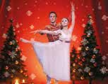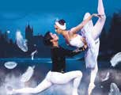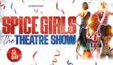

The Nutcracker

Sun, 11 Oct, 2pm

The beloved Christmas classic returns! After last year’s acclaimed tour, Crown Ballet® brings back its dazzling production of The Nutcracker, Tchaikovsky’s timeless masterpiece.
Band A: £31, Band B: £29 (Concessions available)
Book tickets for The Nutcracker and Swan Lake at the same time and receive a discount of £5



The Carpenters Songbook

Thu, 15 Oct, 7.30pm

The Carpenters Songbook is one of the most authentic recreations of the music from The Carpenters. Superb musical arrangements are performed by a fine line up of talented and experienced musicians.
Band A: £26.50, Band B: £24

Swan Lake

Sun, 11 Oct, 7pm

The world’s most famous ballet returns! Crown Ballet® is proud to present a breathtaking new staging of Swan Lake, Tchaikovsky’s iconic masterpiece of
romance, mystery, and classic ballet beauty.
Band A: £31, Band B: £29 (Concessions available)



KPOP Fantasy

Fri, 16 Oct, 7.30pm

KPOP Fantasy is a high-energy theatrical celebration of the global phenomenon that is K-pop. Blending electrifying choreography with outstanding live
vocals, this immersive stage show brings the spectacle, precision, and passion of
K-pop to life in a thrilling theatre experience.
Band A: £25, Band B: £23

The Spice Girls Theatre Show

Wed, 14 Oct, 7.30pm

The girls have put together a very special theatre show with a fun party vibe. They’ll be performing all your favourite Spice Girls hits with their superb backing band, impressive vocals,
dance routines, and stunning authentic costumes.
Band A: £25, Band B: £23.50
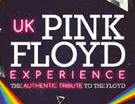

UK Pink Floyd Experience

Sat, 17 Oct, 7.30pm

Lose yourself in The Songs From Every Album Tour in 2026! Featuring songs from every one of Pink Floyd’s 15 studio album legacy. With extraordinary accuracy and a stunning light show - you’ll hear the songs you love, no matter which era of Pink Floyd you prefer.
Band A: £30, Band B: £27.50

The Illegal Eagles: Hotel California Sun, 18 Oct, 7.30pm
Renowned for their flawless vocals, stunning guitars, and an uncanny ability to recreate the legendary sound of the Eagles, the Illegal Eagles have earned a reputation as one of the most accomplished and popular live acts in the UK.
Band A: £38.50, Band B: £37
Kevin Bloody Wilson: Fair Dinkum Funny Tue, 20 Oct, 7.30pm
Sharing the stage once again with his not-so-secret weapon — his retirement fund, JENNY TALIA from Australia — Kev’s bringing
an all-new show packed with the songs and stories that made him a legend.
£37, 16+
NO ADDED FEES!

Take comfort in booking your tickets without paying those extra fees.

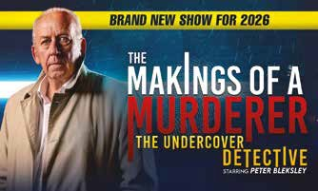
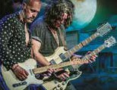
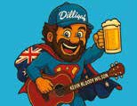
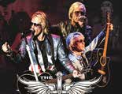

The Bon Jovi Experience

The Makings of a Murderer
Wed, 21 Oct, 7.30pm
Join Peter Bleksley, a founding member of Scotland Yard’s undercover unit and former star of Channel 4’s Hunted, as he lifts the lid on the most dangerous and hidden aspects of murder investigations.
Band A: £28.50, Band B: £27.50, 16+

Thu, 22 Oct, 7.30pm
Direct from London’s West End, get ready to rock your way through an
unforgettable journey with the only show to be endorsed
by Jon Bon Jovi himself!
Band A: £29, Band B: £27

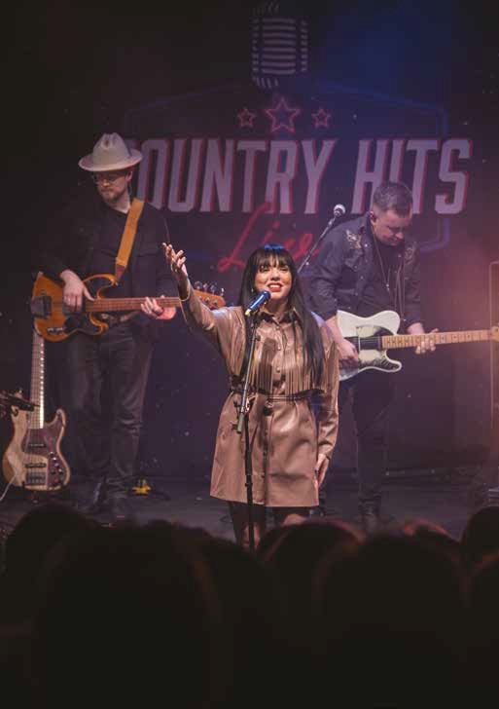

Country Hits Live

Sat, 24 Oct 2026, 7.30pm
Prepare to be taken back through the history of country music featuring songs from Johnny Cash, Willie Nelson, Dolly Parton, Shania Twain, Garth Brooks right through to Taylor Swift and Luke Combs.
Band A: £31, Band B: £28

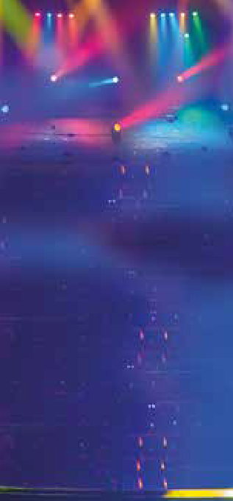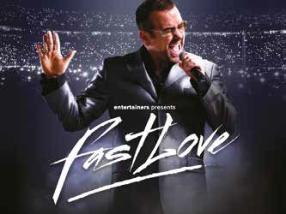
FOR
HIRE
For more information phone: 01634 338300 or email: theatresadmin@ medway.gov.uk

Fastlove
Fri, 23 Oct, 7.30pm
Direct from London’s West End, this is the world’s favourite George Michael celebration! Now touring in 18 countries, selling over 500,000 tickets worldwide. Join us for one very special night as we celebrate the late, great George Michael.
Band A: £32.50, Band B: £30.50
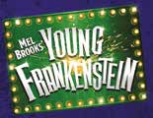

Mel Brooks’ Young Frankenstein

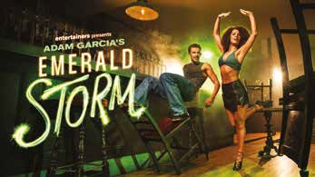
Fri, 30 – Sat, 31 Oct, 7.30pm & Sat, 31 Oct, 2.30pm

Emerald Storm
Sun, 25 Oct, 7.30pm
Direct from the West End, Emerald Storm is the electrifying new dance phenomenon from Adam Garcia, the acclaimed stage and screen star behind some of theatre’s biggest hits. Fusing the fire of Irish dance with the grit of urban tap, this high-octane production explodes with rhythm, passion and pure spectacle.
Band A: £34, Band B: £31
Three Towns Theatre Company presents - Mel
Brooks’ madcap comedy
collides with Mary Shelley’s classic monster tale in
the musical of… Young Frankenstein.
Band A: £19, Band B: £17
Ages 12+

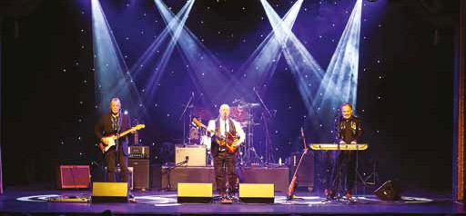

Sensational 60s
Sun, 1 Nov, 7pm
The Sensational 60s Experience is the biggest 60s show on tour. Featuring an incredible ensemble of original artistes and band members, this is the ultimate festival of nostalgia that will have you stepping back in time to that magical decade of music and memories.
Band A: £31, Band B: £29.50
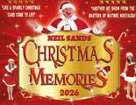
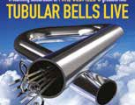
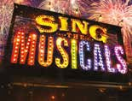

Christmas Memories

Tue, 3 Nov, 2pm

Neil Sands and his wonderful cast return with a brand-new production of their must-see Christmas cracker! Get
ready for a magical afternoon packed with festive joy and heartwarming nostalgia, with over 60 timeless Christmas songs and carols you love.

Band A: £15.50, Band B: £13.50,
concessions available

Tubular Bells Live

Thu, 5 Nov, 7.30pm

A stunning celebration of Mike Oldfield’s greatest hits with internationally renowned Tubular Bells maestro Phil Toms and his 10-piece electro-acoustic ensemble.
Band A: £33, Band B: £30

Sing the Greatest Hits

Fri, 6 Nov, 7.30pm

The ultimate live sing-along, featuring giant video lyrics and the greatest hairbrush anthems of all time! Sing your heart out to the likes of Queen, Bon Jovi, Katy Perry, Abba, The Killers, Guns N’ Roses, AC/DC, Adele, Oasis, Bryan Adams, Eminem, Whitney Houston, Madonna, Bonnie Tyler and many more.

Band A: £27, Band B: £24

The Magic of Motown

Sun, 8 Nov, 7.30pm
Seen by millions, The Magic of Motown is back! It’s no surprise that this show is one of the biggest success stories in British theatre history. Come and celebrate as we Reach Out and show you there ain’t no mountain
high enough with the biggest Motown party of the year.
Band A: £32, Band B: £30

The Stylistics

Tue, 10 Nov, 7.30pm
The Stylistics recorded a ten straight top ten hits during the early 1970s including the Grammy nominated hit You Make Me Feel Brand New, plus Can’t Give You Anything (But My Love), I’m Stone in love With You, Let’s Put It All Together, Sing Baby Sing and many more.
Band A: £41.50, Band B: £37.50

That’ll Be Christmas

Thu, 12 Nov, 7pm
That’ll Be Christmas is back with a brand-new version of the beloved show to bring you all your favourite festive classics in one spectacular, feel-good evening, guaranteed to get you in the Christmas spirit!
Band A: £33, Band B: £31

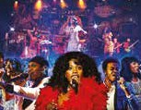
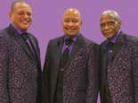
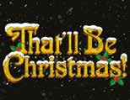
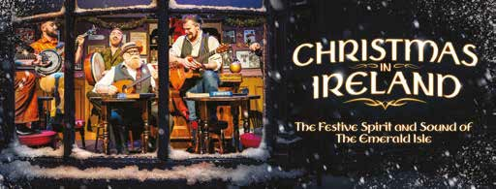

Christmas in Ireland
Wed, 11 Nov, 7.30pm
This Christmas, experience the heart, humour and spirit of Ireland, with Christmas in Ireland. Be transported to a magical Christmas Eve inside a traditional Irish pub, where friends, old and new, gather to share songs, stories and memories of Christmases gone by.
Band A: £30, Band B: £27.50

From CBBC’s So Awkward

Ellie Clayton
as Cinderella
TV Soap Star

Zaraah Abrahams
as the Wicked Stepmother
He’s Back!

Andrew Curphey
as Buoons

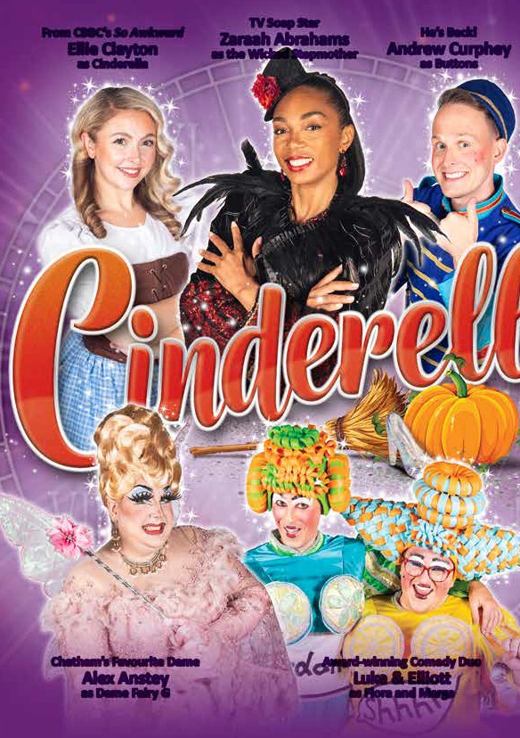
Chatham’s Favourite Dame

Alex Anstey
as Dame Fairy G
Award-winning Comedy Duo

Luke & Ellioo
as Flora and Marge

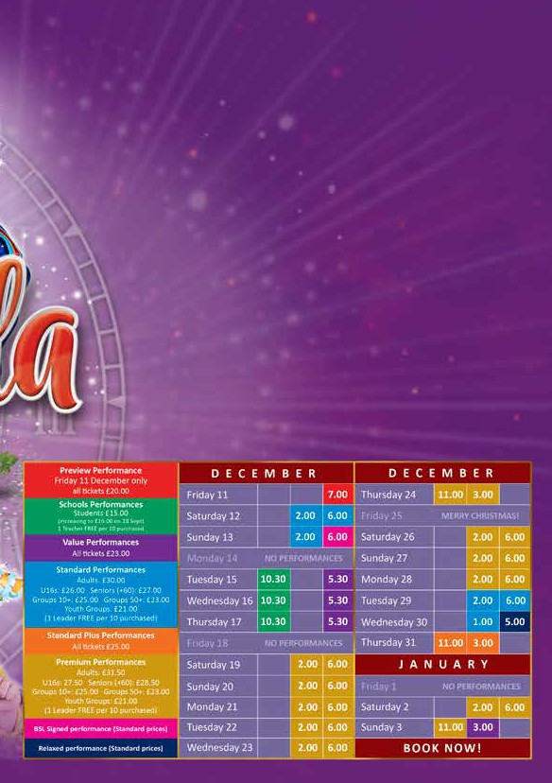
The Legendary Chatham Pantomime returns!

This Christmas, have a BALL at the best-loved panto of them all, with this year's spellbinding pantomime Cinderella.
TV Soap star and fan-favourite, Zaraah Abrahams, stars as the Wicked Stepmother who will do her upmost to stop Cinderella’s happily-ever-aaer!
She’ll be joined by CBBC’s So Awkward star Ellie Clayton as the belle-of-the-ball, Cinderella, whilst her Ugly Stepsisters will be played by award-winning comedy duo Luke & Ellioo.

Chatham’s favourite dame, Alex Anstey returns as the wand-waving Fairy Godmother, whilst the hilarious Andrew Curphey is back
with some brilliant buﬀoonery as Buuons!

This cappvapng producpon is once again brought to you by the team behind last year’s smash hit Sleeping Beauty. Join us for a classic tale of magic and true love, along with breathtaking special eﬀects, toes-tapping live music and plenty of panto fun and laughter.

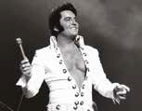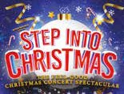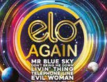

Ben Portsmouth: This is Elvis

Fri, 13 Nov, 7.30pm

Ben is not just a tribute artist; he is the real deal, being regarded as the closest living performer to the legendary Elvis Presley. With global success in over 20 countries, Ben brings energy, passion and authenticity.
Band A: £35, Band B:
£32 Under 16s must be accompanied by an adult, 7+
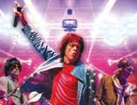

The Rolling Stones Story

Thu, 19 Nov, 7.30pm

You can now relive all these classic hits in a high energy concert celebrating the music of the world’s greatest rock ‘n’ roll band. Let’s spend
the night together in the company of Mick and the boys and you will experience a truly authentic Stones spectacle!
Band A: £29, Band B: £26

Step Into Christmas

Tue, 17 Nov, 7.30pm

Get ready to Step Into Christmas once again for the most magical, feel-good show of the year! After a
sensational run, they’re back – bigger, brighter, and more festive than ever before.
This spectacular Christmas concert is the ultimate way to kickstart your festive celebrations.
Band A: £32, Band B: £30
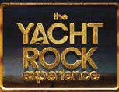

The Yacht Rock Experience:
Ride Like the Wind

Fri, 20 Nov, 7.30pm

Embark on a nostalgic voyage through the iconic age of melodic rock with The Yacht Rock Experience. This brand-new production pays homage to the smooth, soulful essence of the Yacht Rock genre.
Band A: £32.50, Band B: £27.50

ELO Again:
Back to the Blue

Wed, 18 Nov, 7.30pm

ELO Again really give you a dramatic taste of what a
legendary ELO concert would have been like back in their heyday, the whole experience is professionally re-enacted with amazing sound reproduction, light show and visual effects.
Band A: £31.50, Band B:
£28.50
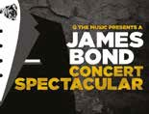

A James Bond Concert Spectacular

Sat, 21 Nov, 7.30pm

Widely considered to be the finest performance of James Bond music since the
originals, they bring the music to life on stage in the most passionate, adrenaline-fueled and polished performance imaginable, featuring all
the hit title songs and some special cues from the scores.
Band A: £37, Band B: £33

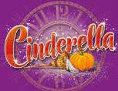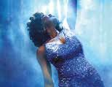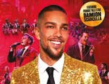

Cinderella 2026

Fri, 11 Dec 2026 to Sun, 3
Jan 2027

Get swept away by the enchantment the spellbinding pantomime Cinderella. Alex Anstey returns as the wand-waving Fairy Godmother, whilst the hilarious Andrew Curphey is back with some brilliant buffoonery as Buttons.
start at £23, with opening night tickets at just £20
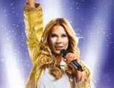

The Celine Experience

Thu, 4 Feb 2027, 7.30pm

A stunning live concert celebrating the music of Celine Dion - brought to the stage in a bold, theatre-scale production. Starring vocalist January Butler, The Celine Experience delivers the power, control and pure vocal brilliance that made Celine one of the greatest performers of all time.
Band A: £32.50, Band B: £30

Queen of the Night: A Tribute to Whitney Houston

Thu, 28 Jan 2027, 7.30pm

Returning in 2027 for another show-stopping celebration, following sold-out tours across the UK, including an arena tour and iconic venues such as the Royal Albert Hall and The London Palladium.
Band A: £32.50, Band B:
£29.50 Under 14s must be accompanied by an adult

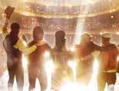

Go Your Own Way –
A Tribute to Fleetwood Mac

Fri, 5 Feb 2027, 7.30pm

A brand new spellbinding show featuring the music from the legendary multiple Grammy Award Winning Fleetwood Mac. Beautifully performed by a highly talented and acclaimed ensemble of musicians.
Band A: £27, Band B: £25
The Best of Frankie Valli & The Four Seasons featuring Matt Terry Sat, 30 Jan 2027, 7.30pm

The Best of Frankie Valli & The Four Seasons is back by overwhelming demand, delivering a spectacular, high-energy celebration of
the timeless music from one of the biggest-selling groups of all time.
Band A: £39.50, Band B: £37.50

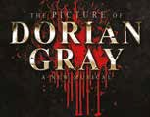
The Picture of Dorian Gray: A New Musical Sat, 6 Feb 2027, 7.30pm

A brand-new musical based on Oscar Wilde’s timeless gothic tale. Starring Kevin Kennedy (Rock of Ages, We Will Rock You, Coronation Street) as Mr Issacs. When a wish binds his fate to a
portrait, Dorian discovers that perfection comes at a cost.
Band A: £38, Band B: £34,
14+

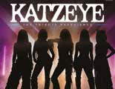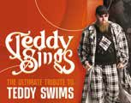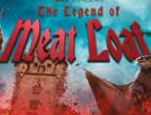

Katzeye - The Tribute Experience

Sun, 7 Feb 2027, 4pm

A spectacular, high-energy live production celebrating one of the world’s fastest rising global pop groups. This electrifying tribute brings together all the biggest
hits, fierce choreography, powerhouse vocals and superstar energy in one unforgettable show.
Band A: £26, Band B: £23
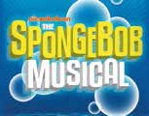

Spongebob The Musical

Wed, 17 Feb to Sat, 20 Feb 2027, 2pm and 7pm

Dive under the sea with the smash-hit SpongeBob The Musical a hilarious, heartwarming, and
electrifying stage adventure for audiences of all ages, presented by GDS.
Band A: £16.50, Band B:
£14.50, concessions available, family 4 ticket: £55

Teddy Sings

Thu, 11 Feb 2027, 7.30pm

This tribute show celebrates the unique blend of soul, pop, R&B, and country that defines Teddy Swims’ sound. Backed by exceptional live production and authentic performance style, Teddy Sings is a must-see act for fans and live music lovers alike.
Band A: £28, Band B: £26

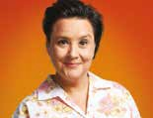

Susan Calman:
Tall Tales

Wed, 24 Feb 2027, 7.30pm

Susan Calman hasn’t been on tour in ten years, but now she’s back with a brand-new show. A decade older, but not necessarily wiser, Susan has found herself in some improbable situations over the years.

£28.50, 14+ only
Hits Out of Hell – The Legend of Meat Loaf Fri, 12 Feb 2027, 7.30pm

Celebrating the life, music and legend of the musical maestro Meat Loaf.
Experience all the hits from what is one of the best-selling artists of all time, culminating over 80 million album sales, a grammy award and the best rock and roll love anthems ever written.
Band A: £27, Band B: £24
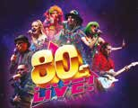

80s Live

Thu, 25 Feb 2027, 7.30pm

Direct from London’s West End, we will be heading down the Atlanta Highway, so bring your jukebox money and get ready to Jitterbug. The ultimate 80s night out, so come dressed to impress as we spin you around
and around for a night to remember.
Band A: £31.50, Band B:
£29.50

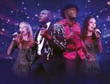

Luther Live & Velvet Voices

Fri, 26 Feb 2027, 7.30pm

Step into a world of soul, romance, and unforgettable grooves with Luther Live & Velvet Voices – the ultimate live theatre experience celebrating the golden era of R’n’B. This show brings the smooth sounds of Luther Vandross, Alexander O’Neal and many others to life.
Band A: £27, Band B: £25
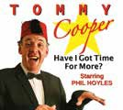

Tommy Cooper – Have I Got Time For More?

Fri, 5 Mar 2027, 7.30pm

Tommy Cooper, one of the greatest ever comedians, is back! Expertly performed by Phil Hoyles - the UK’s number one impersonator - he brings you all of the ‘tom’-foolery, jokes, songs, laughs, magic, failed magic, and energy,
that the original funnyman presented all those years ago!
Band A: £21.50, Band B: £20

Legend – The Music of Bob Marley

Sat, 27 Feb 2027, 7.30pm

An unforgettable evening celebrating this musical icon in one fantastic stage show. Direct from a sell-out show at London’s Adelphi Theatre, showcasing the magic of Marley. It captures the charisma and culture of an icon gone too soon.
Band A: £30, Band B: £29

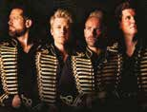
Phantoms of the Popera with G4 Sun, 7 Mar 2027, 7.30pm

Join Jonathan Ansell, Michael Conway, Mike Christie and Duncan Sandilands on a rollercoaster of breathtaking show-tunes, riding the high and lows of uplifting melodies, heart-rending ballads and climactic anthems.
Band A: £35, Band B: £30.
Meet & Greet: £34.50 (in addition to ticket)

Guilty or not Guilty: The Jeremy Bamber White House Farm Murders, with Mark Williams-Thomas

Thu, 4 Mar 2027, 7.30pm

Delving into one of the most infamous and debated murder cases in British criminal history. Confront one of the UK’s true-crime
mysteries and cast your own verdict: guilty… or not guilty?
Band A: £27, Band B: £24, 14+

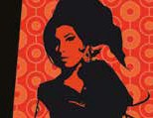
The Amy Winehouse Band: The Back to Black 20th Anniversary Tour Sat, 13 Mar 2027, 7.30pm

Amy’s original band, who were with her throughout her meteoric rise, perform Back to Black in full plus other Amy Winehouse classics, keeping Amy’s musical legacy alive.
Experience these modern classic songs performed live.
Band A: £33.50, Band B:
£29.50

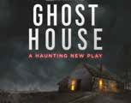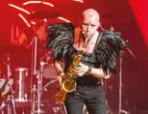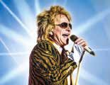

Ghost House

Sun, 14 Mar 2027, 7.30pm

A brand-new haunting play, GHOST HOUSE follows three best friends who, after months of travelling the world, arrive at a remote island lodge for their very last stop. It should be a celebration. Instead, it becomes something far more sinister.
Band A: £35, Band B: £32
14+
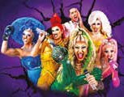

Queenz – Battle of the Divas

Sat, 20 Mar 2027, 7.30pm

They’ve headlined in Las Vegas, supported global icons Chappell Roan & Christina Aguilera, and sold over 250,000 tickets worldwide. Now, the Queenz go head-to-head with hits from over 20 legendary divas in the fight for pop supremacy.
Premium: £39.50, Band A:
£29.50, Band B: £27.50

London Symphonic Rock Orchestra

Tue, 16 Mar 2027, 7.30pm

The boundary-breaking London Symphonic Rock Orchestra return with a brand-new set. Performing legendary anthems with breathtaking intensity, fusing the majestic power of the symphony orchestra with the rebellious energy of rock.
VIP: £70, Band A: £49,
Band B: £41.50
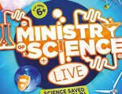

Ministry of Science: Science Saved the World

Sun, 21 March 2027, 2pm

The UK’s favourite science team are back and more explosive than ever!
100% educational. 200%
entertaining. 300% explosive.
400% fun.
Band A: £17.50, Band B:
£16.50 (concessions available) Family 4 ticket: £64

Some Guys Have All The Luck – The Rod Stewart Story
Fri, 19 Mar 2027, 7.30pm

Join us on a musical journey that spans six decades. Every song is performed with swaggering showmanship by charismatic front man, Paul Metcalfe, alongside authentic costumes and sensational live musicians.
Band A: £28, Band B: £26.50
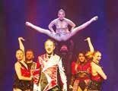

Cirque:
The Greatest Show

Thu, 25 Mar 2027, 7pm

Cirque explodes with a brand-new show more breathtaking than ever before! A fusion of musical theatre and circus acts, taking the circus meets musical theatre spectacle to new heights.
Band A: £32.50, Band B: £30, concessions available, under 14s must be accompanied by an adult

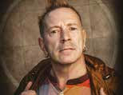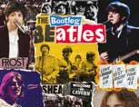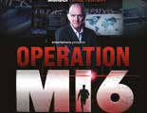

John Lydon

Sun, 11 Apr 2027, 7.30pm

He’s a legend and an icon, a revolutionary and an immortal. John Lydon – aka
Johnny Rotten – changed the face of music and sparked a cultural revolution..
VIP: £90 (seats in the front four rows, meet & greet, a goody bag, autograph and photo of John), Premium: £50 (includes a goody bag),
Band A: £35, Band B: £33


The Ultimate Classic Rock Show

Fri, 23 Apr 2027, 7.30pm

An evening of the very best classic rock anthems from legends past and present! A roller coaster journey of hit after hit, live with stunning accuracy and high energy accompanied by an incredible light and projection show.
Band A: £32, Band B: £30

Bootleg Beatles

Mon, 12 Apr 2027, 7.30pm

From a tiny stage in a famous Liverpool cellar to a rooftop in central London, the Beatles played a vast number of
live performances in their eight-year reign. Whether in theatres, stadiums or TV
studios, many of these proved to be groundbreaking events.
Band A: £42.50, Band B: £38.50

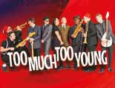

Too Much Too Young

Sat, 24 Apr 2027, 7.30pm

The Music of 2Tone & Beyond is a high-energy, two-hour live show celebrating the
ska sound that shaped generations. This feel-good journey traces ska’s roots from Jamaica to its explosive British revival of the late
’70s and ’80s, honouring the artists who made it a global phenomenon.
Band A: £27.50, Band B: £26

Operation MI6:

Thu, 22 Apr 2027, 7.30pm

Former MI6 intelligence officer Matthew Dunn takes audiences inside the secretive world of Britain’s foreign intelligence service in a gripping live theatre experience. Dramatic recreations and real-world insight, you’ll discover how
intelligence officers operate.
Premium: £40, Band A:
£36, Band B: £32.50

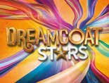

Dreamcoat Stars

Fri, 30 Apr 2027, 7.30pm

Feel the spine-tingling vocal power of four sensational singers from the global
hit show Joseph and the Amazing Technicolor Dreamcoat coming together for an unforgettable evening. Guaranteed to leave you wanting more, while singing your favourite songs all the way home!
Band A: £28, Band B: £25

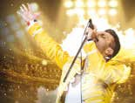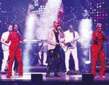

The Show Must Go On: The Ultimate Queen Tribute

Fri, 7 May 2027, 7.30pm

Get ready to relive the magic, the music, and the legend.
The Show Must Go On is the ultimate Queen tribute
experience — an electrifying, high-energy celebration
of one of the greatest rock bands of all time.
Band A: £29, Band B: £27

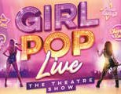

Girl Pop Live

Sun, 23 May 2027, 2pm

A explosion of music, dance, and excitement! Join us for the ultimate pop concert and celebrate the biggest hits from eight of the hottest artistes of the moment. With tributes to Taylor Swift, Miley Cyrus, Olivia Rodrigo, Billie
Eilish, Sabrina Carpenter, Dua Lipa, Chappell Roan and Zara Larson.
Band A: £22.50, Band B: £21

Lost In Music

Fri, 14 May 2027, 7.30pm

Embark on an electrifying journey through the sensational 70s. Our world class band and dazzling vocals are set to transport you straight to the heart of disco fever. Get ready to re-live timeless hits from icons like Donna Summer, Gloria Gaynor, Earth, Wind & Fire, Sister Sledge and Chic.
Band A: £32, Band B: £30


The Westlife Experience

Sat, 29 May 2027, 7.30pm

Get ready to relive the magic of Ireland’s biggest boyband - the ultimate tribute to one of the most iconic pop groups. Whether you’re a lifelong fan or hearing the classics for the first time, this show promises a night of nostalgia, feel-good music, and singalong anthems for all ages.
Band A: £27, Band B: £25
Ronnie, Reggie and Me with Fred Dineage Wed, 19 May 2027, 7.30pm

TV legend Fred Dinenage is one of the very few people granted access to the Krays’ inner circle. Join him as he shares untold stories. Hosted by broadcaster Alex Dyke, this gripping show brings you closer to two of the most feared figures in criminal history.
Band A: £32, Band B: £30


Boyband in the Buff

Thu, 10 Jun 2027, 7.30pm

The ultimate throwback concert with a cheeky twist - starring Gareth
Gates and seriously talented (and seriously ripped) performers. Stripped back to slick harmonies, killer
choreography and undeniable charisma, the boys bring the hits of the ‘90s and ‘00s to life.
Premium: £50, Band A:
£35, Band B: £32, 18+

NOW BOOKING at The Central Theatre
Book early to avoid disappointment
New shows are being added all the time. Visit MedwayTicketsLive.co.uk for details and follow
TheCentralAndBrookTheatres on Facebook for show announcements.
Seven Drunken Nights Wed, 14 Apr 2027

Kentish Players present Shrek The Musical Fri ,18 to Sun, 20 Jun 2027
In the Air Tonight Thu, 1 Jul 2027
Theatre information
The Central Theatre: 170 High Street, Chatham, Kent ME4 4AS (ME4 4RG for sat navs)
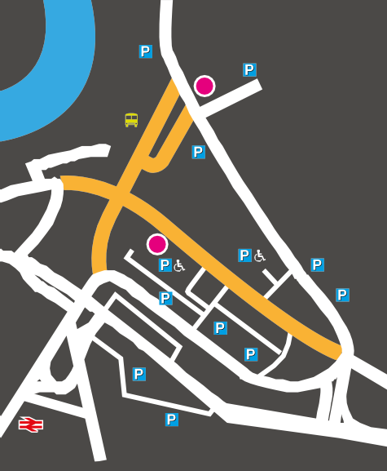
- The box office is open Monday to Saturday, 10am to 5pm or until 15 minutes after curtain up on performance nights. Doors open 30 minutes before curtain up.
To Chatham Maritime and Gillingham

The Brook Theatre
Chatham Bus Station
Pentagon Shopping Centre
The Central Theatre
To Rochester
To Maidstone and M20
To Rainham
o
R
ck
o
D
y
a
w
- Tickets must be paid for in person, by phone, credit card or by post within three days of reservation or 30 minutes before curtain up (whichever is the earliest).
1
23
A
d
a
d
e
M
r
e
v
i
R
Whiffens Ave
- Tickets should be considered non-exchangeable and non-refundable and we advise customers to check their tickets upon receipt.
Br
The
nt Way (Buses/taxis only)
itary Rd
y
S
t
- The Central and Brook Theatre reserve the right to introduce, remove or alter special offers and discounts without notice. Discounts will not be applied retrospectively.
M
ook
d
l
i
M
e
A
d
2
w
a
- If you are disabled and require assistance to visit the theatres, then become a member of the Assisted Access Scheme and buy an additional ticket for your assistant at half price.
A
2
High Str
he
T
W
a
t
e
r
a
f
r
o
o
R
r
o
n
a
M
- Wheelchair access and spaces are available at both theatres. Please advise staff of your requirements when booking. Access to The Brook Theatre is by the electronic platform on the front steps or via the ramped entrance at Whiffens Avenue. Access to The Central Theatre is by the front entrance, via a platform, or by the side entrance by the Blue Badge holder car park.
)
nly
s o
rian
dest
Best Street
eet (pe
N oad
R
ew
ro
o
k
B
U
n
i
Maidstone Road A230
o
n Street
Railway Street
- Management reserves the right to refuse admission.
- Customers cannot bring their own alcohol into the theatres. Any alcohol will be taken away and not returned.
A2
- For your safety, you are advised that you may be subject to a bag search.
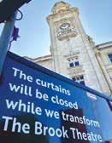
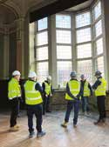

Keep up to date with The Brook Theatre renovations: follow @Medway_Culture

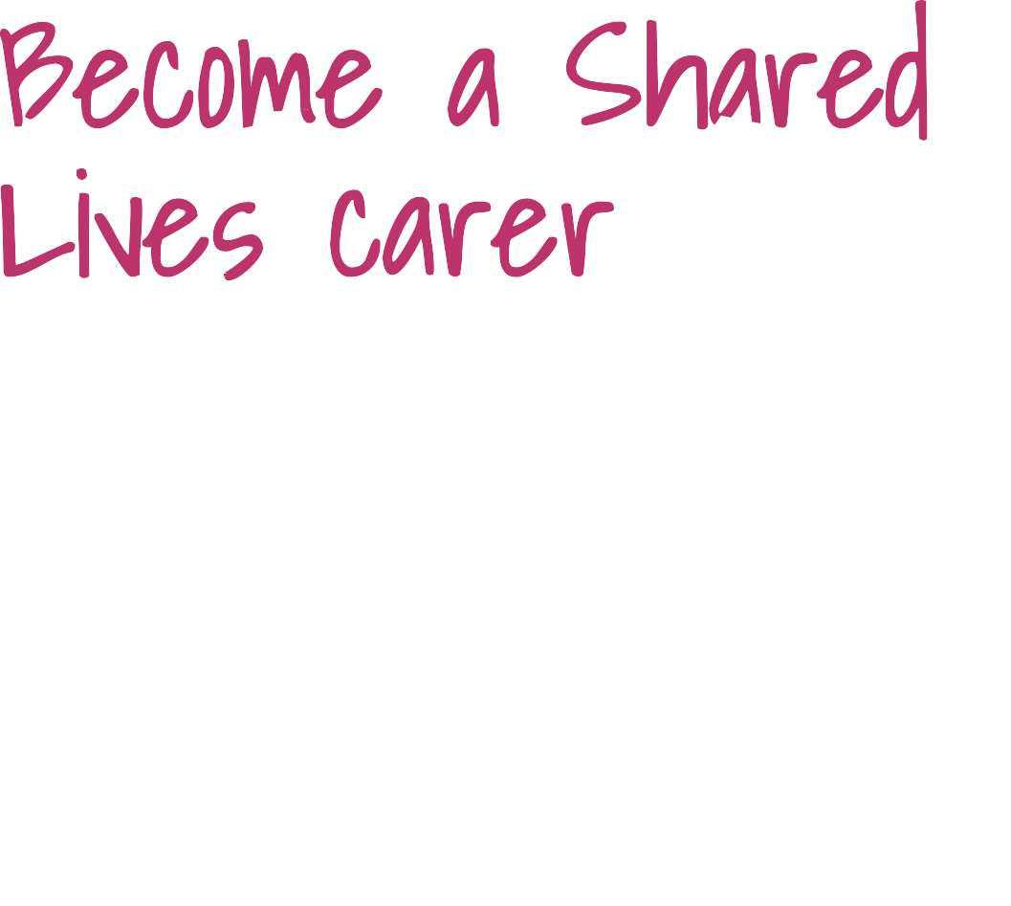
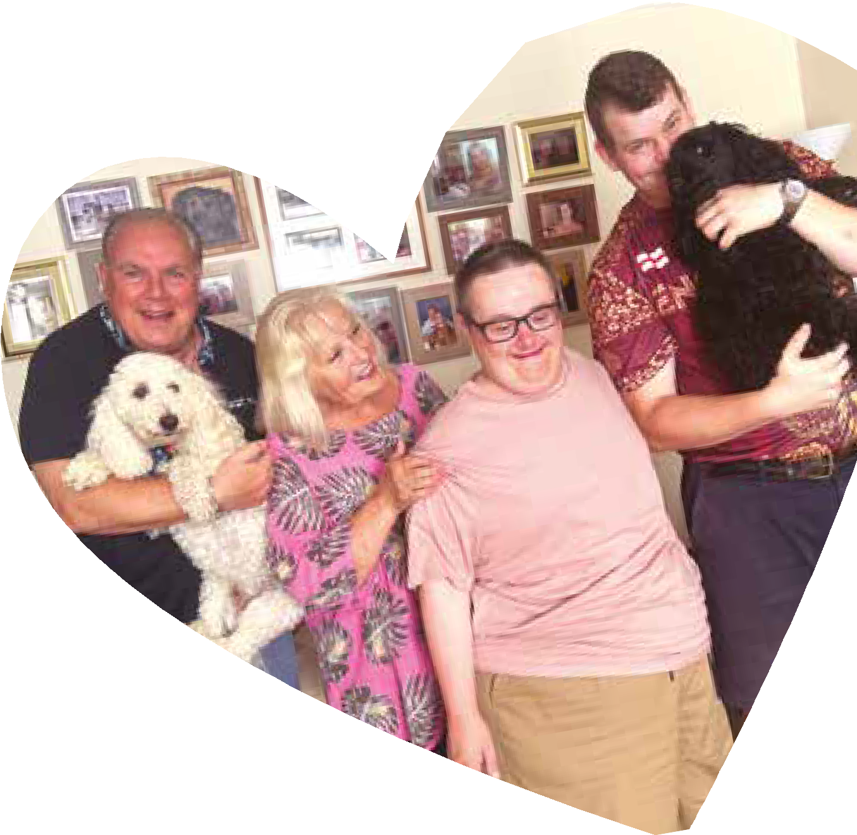
Open-up your home and change a life. Support an adult in Medway to
become more confident and independent.

Earn up to £2,427 per month
- Work around your existing job and commitments
- Full training and support given by a friendly team

Visit Medway.gov.uk/SharedLives
or phone 01634 337100 to find out more today




Scan me

